PRESS RELEASE
EUROCYBCAR: A BASQUE COMPANY ANALYZES THE CYBERSECURITY IN VEHICLES
Do you know if your car is safe from a cyberattack?

EUROCYBCAR, in its laboratory in Vitoria-Gasteiz, analyzes the level of cybersecurity that vehicles offer to raise awareness of manufacturers, organizations and society about the importance of this point.

Madrid, 05 December 2018

Nowadays would anyone buy a car that did not have airbags or safety belts? Then why do people purchase vehicles without a minimum level of cybersecurity, risking their privacy and, even, their lives?

For years, automobiles have continuously incorporated new technologies. Bluetooth, GPS, Wi-Fi or intelligent keys are already common systems in our cars. And in a short time, every vehicle will be connected to the Internet and to each other. However, in addition to the advantages that these systems provide, they also incorporate signiﬁcant risk, because they provide access points to the vehicle that cybercriminals can use.

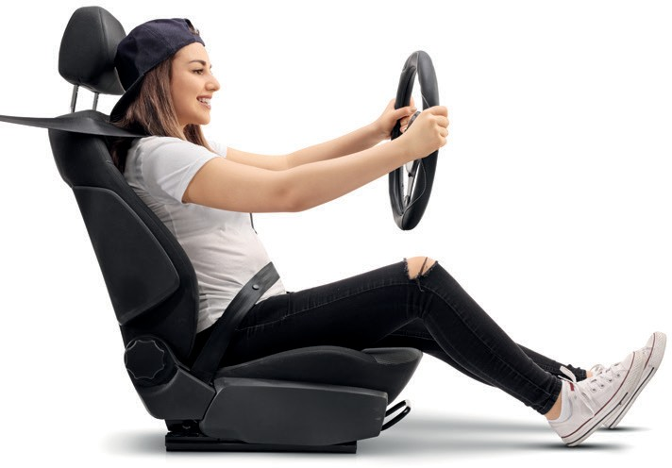

Once they have accessed a vehicle’s computer system-physically or remotely-, crackers can steal data from the vehicle and its passengers, or even take control of the car, unless it has an adequate level of cybersecurity.

The Spanish company EUROCYBCAR, located in the Álava Technological Park, has developed the ﬁrst test which analyzes the cybersecurity level of brand new cars. This enterprise was founded with two objectives: ﬁrst, to check the protection level in a car in confronting cyberattacks against its connectivity systems which might take place physically or remotely, and second, to assess how those actions affect the passengers' security, their privacy and the integrity of the vehicle’s systems.

The project already has the support of organisms and institutions such as ENISA, INCIBE, the Basque Cybersecurity Center, the Spanish Ministry of Science, Innovation and Universities, the Spanish Ministry of Economy and the Spanish Ministry of Economy and Business, among others. It has also been extremely well received in the European Commission’s H2020 Programmes Committee by countries such as Germany, France, Sweden, Greece, Netherlands and Israel.

EUROCYBCAR has been ofﬁcially presented by its CEO, Azucena Hernández, at a number of international events including 12ENISE, organized by the Spanish National Institute of Cybersecurity -INCIBE-, and Basque Cybersecurity Day, promoted by the BCC, with an overwhelmingly enthusiastic response by the companies and institutions present.

EUROCYBCAR Company, specialized in vehicle cybersecurity analysis, has decided to establish its test centre in the Álava Technological Park in Miñano, where the Basque Cybersecurity Centre (BCSC) is also located, with the goal of helping to create a cybersecurity hub in the south of Europe. EUROCYBCAR will receive support from the SPRI Group through BICAraba, also located in the Park.

The bet on EUROCYBCAR by Euskadi signiﬁes the conﬁrmation of the important role of the BCSC in Europe, which is compounded by the importance of the region’s automotive industry, as well as the research framework existing in the Basque Network of Science and Technology.

For more information: info@eurocybcar.com Phone number: +34 619 291 892

